Nithin S
221IT085

IT150 Lab Assignment 1

1. Develop programs that implements class and use it with objects illustrating their declarations, definition, and accessing members. Write a C++ program to create a class called Person that has private member variables for name, age and address etc,.

CODE

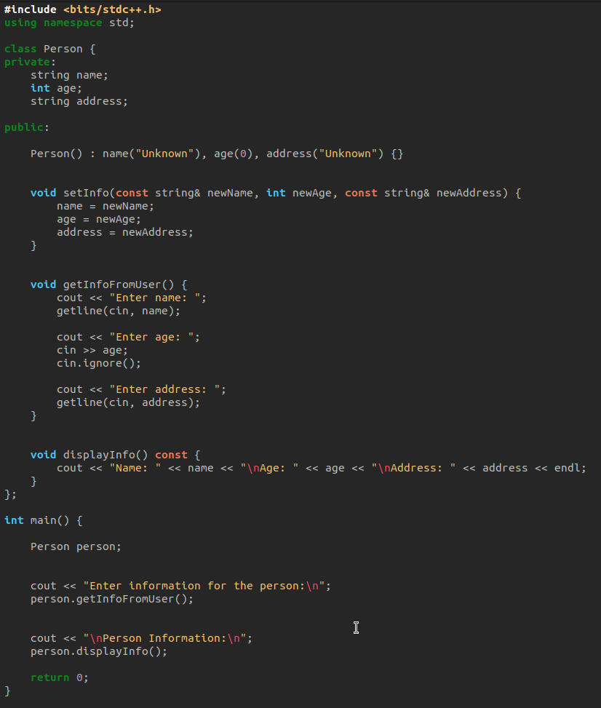
OUTPUT

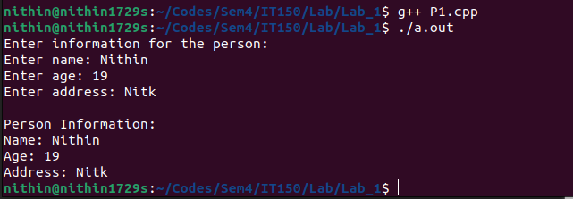

2. Write a C++ program to create a class called Car that has private member variables for brand, model, engine etc.

CODE
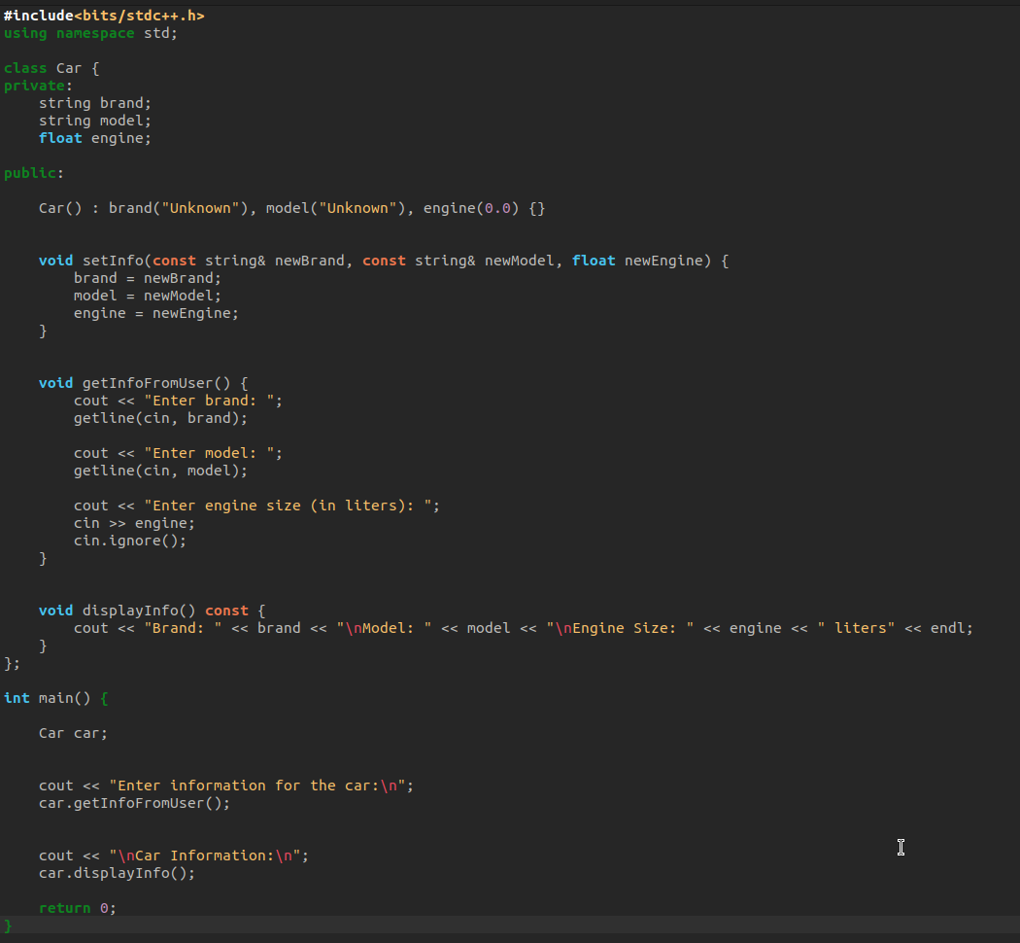

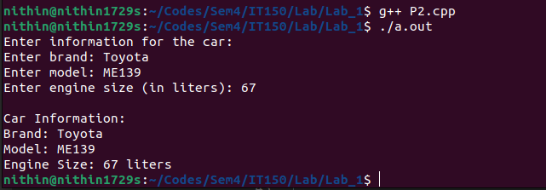
OUTPUT

3. Write a program to illustrate the working of public and private in C++ Class.

CODE

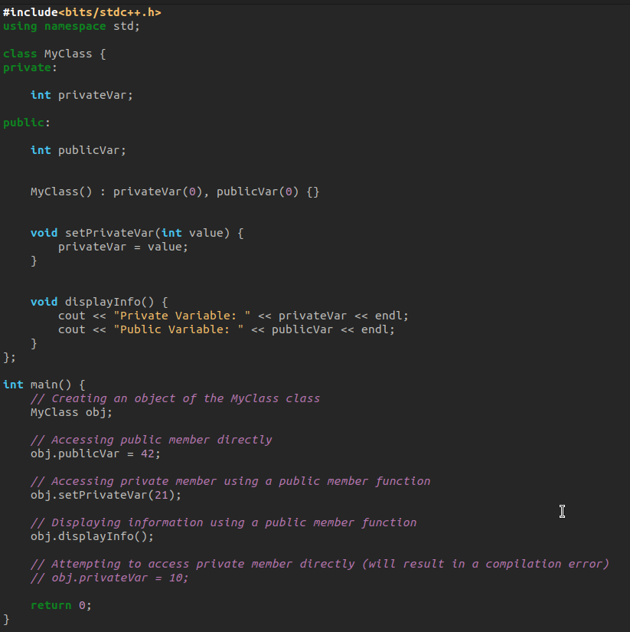

OUTPUT

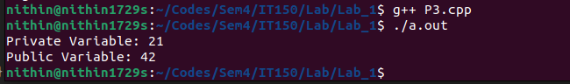

After Uncommenting obj.privateVar =10 line the compilation of the code throws an error, which is not the case in public variables

